For Immediate Release
Contact: Stacey Kumagai, Media Monster Communications, Inc. 818.506.8675 mediamonster@yahoo.com

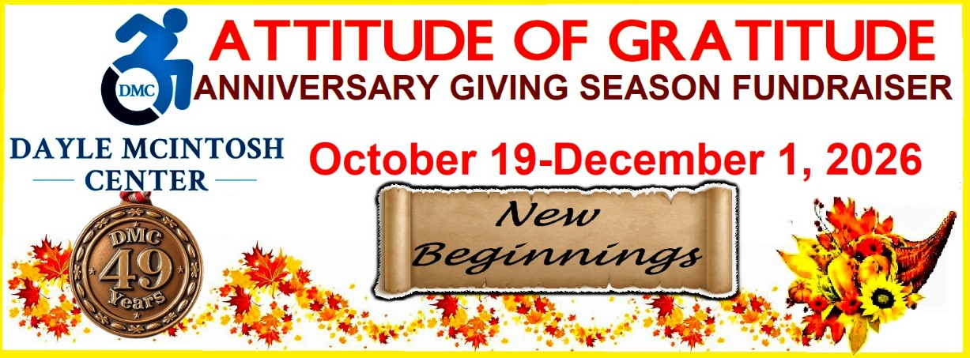
Image Description: Masthead graphic- Attitude of Gratitude Anniversary Giving Season Fundraiser, October 19 -December 1, 2026. DMC blue logo on left; Celebrating 49 years. bronze embossed medal. "New Beginnings" theme scroll with Fall foliage in orange /yellow with a cornucopia in lower right corner holding flowers, leaves and mini pumpkins. Image has yellow border

Dayle McIntosh Center Creates New Beginnings with Immersive Internship Program
As Independent Living Center Celebrates 49th Anniversary

Anaheim, CA --- New Beginnings. The Dayle McIntosh Center for the Disabled (DMC) (https://daylemc.org) is celebrating 49 years as Orange County’s only Independent Living Center for people with disabilities, older adults and Veterans. This year’s anniversary themed “New Beginnings” brings with it new changes, partnership collaborations, and growth opportunities with the exciting development of a one-of-a-kind unique college internship program through the 501(c)(3) organization to further support new beginnings for students into their career trajectory and advocacy service goals.

“At DMC we thrive to create a career building and cross collaboration environment for our volunteers and interns, the goal is to create an environment of growth and skill building for both and being able to cross over in their tasks. In the DMC internship program initiated by our Volunteer Coordinator Raquel Velarde, students are able to manage a small caseload with the support and supervision of the program’s lead and directors. In addition, on a monthly basis we host a volunteer peer support group so that both interns and volunteers gain knowledge about additional opportunities available and they get to hear about the tasks they perform from one another,” states Michelle Ramos, DMC’s Director of Community Support Services. “At the moment we are in the initial stages of mapping out the structure for interns at DMC in the hope to continue having multiple connections through local and national colleges. Long term we would like to have multiple students through different semesters manage a small caseload and contribute to DMC’s great success. “

Ramos went on to explain that “community partners have sparked interest in placing interns to gain skills and knowledge through our organization,” which is a very important momentum surge DMC hopes to make a strong impact for the community.

According to the Association of University Centers on Disabilities, 45.50% of people with disabilities in the State of California are employed and 39,512,000 Individuals with disabilities living in communities. DMC’s efforts to provide college internships and volunteer opportunities working in partnership with educational institutions is essential to grow knowledge about how Orange County’s Independent Living Center works and the community it serves is vital to overall community outreach, development and understanding for better relating.

“The internship program is an opportunity for local college students to volunteer/intern at DMC while also obtaining required hours/experience needed for college courses and/or completion of degrees. The program is a learning initiative designed for undergraduate and graduate students in various social services/humanities degrees and is specifically for students in local colleges looking to complete fieldwork, gain hours or weeks of experience or shadowing for their courses in undergraduate and graduate programs. In these opportunities student interns gain job training and match the theories of their courses to their firsthand cases at DMC. They can ask questions, shadow/observe and learn from service providers and take their experiences to their future jobs,” shares Raquel Velarde, DMC’s Volunteer Coordinator who is spearheading DMC’s Internship Program.

Velarde further explains, “The program aims to build a gap between the theory of practice and real-on job scenarios. Currently, the colleges we are working with are Golden West College (GWC) in Huntington Beach and Westcliff University in Irvine and currently, the general area of study is Social Servies or Humanities majors. We are open to majors that vary such as Child Education, Business, Nursing and more case by case. The process begins with an internship application through the Volunteer Platform Galaxy Get Connected. Followed by an interview – in some cases with student and professor for a DMC overview, onboarding, training and fulfillment of hours which vary by college or course for student enrolled.”

With California being the top state where internships are most competitive, numerous educational institutions in the Southern California region are quick to recognize the value of internships in connecting academic learning with real-world life and work experience to accomplish career goals to gain skills to enhance and successfully complete many different degree programs. DMC being a peer-led organization with multiple on-going programs and service needs is unique whereby a targeted approach to internships is essential for the Independent Living Center to fulfill multiple areas of need.

“We utilize every volunteer and intern’s expertise to customize their experience. Our Volunteer Coordinator has a great talent for finding strengths during the interviews she conducts with the interested applicants allowing them to be placed in their role of preference and possibly cross collaborate. In the future, we would like to continue expanding roles available to our interns to gain more experience and skills and implement a system in which they are able to select multiple roles that fit their strengths and utilizes their skills. The reason for our focus is to assist some of our high impacted programs manage the high caseload,” explains Ramos.

Outlined, some of the initial DMC Internship roles are as it follows: Grants, Personal Assistant Services, Assistive Technology, Housing, and Outreach. Beyond the actual tailoring and customization for the internships, Velarde pays careful attention to these focus areas to meet requirements of their course for the student’s degree. Going beyond this point is what makes DMC’s Internship Program experience different from other internships.

“With collaboration from the school’s professors, the students are open to learn new skills and areas to focus on. For example, recent volunteer interns were completing fieldwork for a course in their Social Services and Humanities major. They directly supported the Housing Program at DMC but also participated in tasks from Blind/Low Vision Services Program. Having our volunteer interns learn from multiple departments provides a well-rounded fieldwork opportunity and on the job training at an Independent Living Center. In the future, I would like to possibly collaborate with schools/professors to create opportunities that meet the needs of both DMC but also fulfill the direct requirements of the course. For example, maybe learning tasks of the course and pairing that with opportunities of need at DMC,” shares Velarde.

One of DMC’s recent Interns, Natalia Ramirez, a student at Golden West College shares a first-time internship lens. “I didn’t have any previous knowledge, but was curious to learn more – to help those in need and I enjoy interacting with people. Being open minded helped me be more appreciative,” states Ramirez. Her internship journey became a discovery process, “I learned I can be a little shy over the phone. (I will) apply knowing how to navigate a conversation with proper vocabulary and will take away skills and memories.”

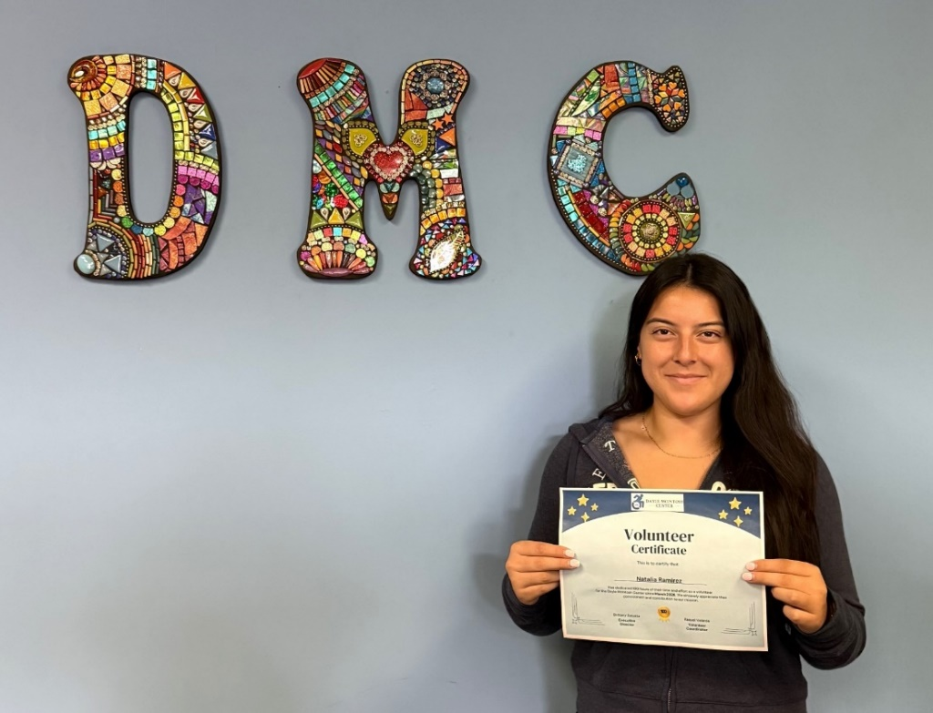 Pictured above: Natalia Ramirez, DMC Intern from Golden West College smiling holding service certificate under DMC mosaic wall artwork.

Ramirez’ advice for anyone interested in exploring the DMC Internship Program: “To put themselves out there and taking a step into the real world will open eyes.” DMC hopes what Ramirez shared is heard by educational institutions because internships in today’s challenging career market matter. According to World Metrics, 89% of employers report that internships help them identify full-time candidates, 63% of U.S. internships are for college students, and 71% of interns report that their internship influenced their career path choice.

“The plan is to continue creating relationships with colleges, currently our Volunteer Coordinator is seeking partnerships with schools that offer ASL classes to be able to also expand opportunities to our Deaf Services Program. Long term I would like to be able to expand the Volunteer program and convert it into a fee for service that creates revenue for DMC and is well established enough to continuously support our team and consumers, shares Ramos.

Velarde adds “A (big picture) goal of mine for the program would be to have the internship cross over into an externship or create a way to have interns apply directly to open job opportunities at DMC and to be able to expand to neighboring counties.”

The organization’s commitment in shaping ‘new beginnings’ paves the way for creating a huge impact to understand the disability, older adult and Veteran community it serves. Opening new doors for the next generation - The internships introduce the organization’s health and human services outreach to grasp “how” Orange County’s Independent Living Center works and serves its growing community.

If you’d like to learn more about DMC’s new Internship Program, call 714-621-3300.
To learn about other additional Volunteer opportunities, go to the Volunteer web page and explore the Galaxy portal HERE.

If you’d like to donate to The Dayle McIntosh Center you can do so by clicking HERE.

For more information on DMC’s programs and services go to https://daylemc.org or call directly at 714-621-3300. For media story inquiries and interviews, please contact Publicist, Stacey Kumagai, Media Monster Communications, Inc. at 818.506.8675.
###

