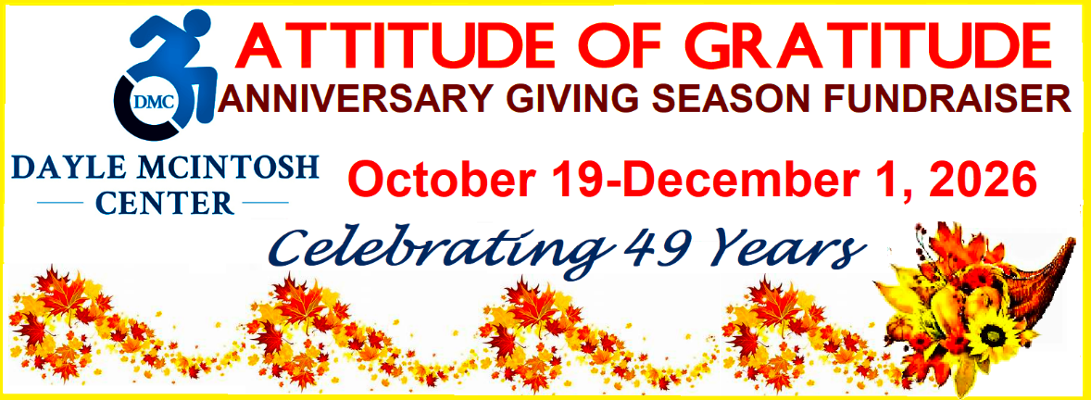
Image Description: Attitude of Gratitude Anniversary Giving Season Fundraiser, October 19 -December 1, 2026. DMC blue logo on left; Celebrating 49 years. Fall foliage in orange /yellow with a cornucopia in lower right corner holding flowers, leaves and mini pumpkins. Image has yellow border.

WHO: Celebrating 49 years, the Dayle McIntosh Center (DMC) https://daylemc.org is Orange County’s ONLY Independent Living Center for people with disabilities, older adults and Veterans. Our mission is, “access and equity by, and for, people with disabilities and older adults.” Peer-led, our organization founded its roots on the disability justice movement through activism and advocacy leading to opening our doors in 1977.
WHAT: DMC Attitude of Gratitude 49th Anniversary Giving Season
WHERE: Donate Online via our website by Clicking HERE: 
Mail donation checks to 501 N. Brookhurst Street, Suite 102, Anaheim, CA 92801. Be sure to include #Gratitude on your check or PayPal notes to qualify for prizes (more below)!

WHEN: October 19-December 1, 2026

WHY: Your gift helps us with our growth initiatives to meet a growing community in need.
HOW IT WORKS: Make a Tax-Deductible Cash Donation to DMC by mail or online and automatically be entered into our prize opportunity drawing. The larger amount you donate, the more chances you have to win rolling you over for the next prize. All Early Bird donors will be part of an Early Bird Prize Drawing on 11/6/2026. Those who don’t win are rolled into the main drawing increasing odds. ALL donors through 12/1 will be entered into the opportunity drawing. The prize drawing will take place on December 3, 2025, what would have been Dayle McIntosh’s 85th birthday. Winners will be notified by phone, U.S. postal mail or email.
We request you provide your email, phone and mailing address so we can notify you if you win.
OTHER WAYS TO HELP: We understand times are tough. If you can’t donate, you can still participate in any of the following ways:
- You can challenge your friends, family and colleagues to donate.
- Have your business or your employer do a year-end tax-write off donation to DMC.
- Ask your employer to do a corporate match towards funds DMC raises during Giving Season
- Circulate our Donor Flyer
- Share our Circle of Support Page
Thank You!

